Foreign Investment in the Caribbean
The West Fails Haiti – Again
By
S. Brian Samuel
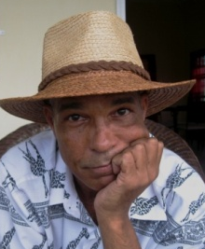

Every year, the Economic Commission for Latin America and the Caribbean (ECLAC) publishes, among other things, a listing of the net Foreign Direct Investment (FDI) flows into the region; country by country. For economists this is a valuable source of data, as it indicates how “well” a country is doing in attracting foreign investments to its shores. I say “well” because not everyone sees FDI as a good thing.
What is FDI? Basically, FDI is a measure of the amount of business investment a country is receiving from abroad: “Investments made by a company based in one country, into a company or subsidiary in another country.” FDI does not include stock market flows; nor does it include remittances from nationals living abroad. FDI can also be negative: sometimes net profits sent abroad are greater than new investments received.
ECLAC’s figures for 2012 are out; and they make interesting reading. Table 1 below lists net FDI flows to the Caribbean. The country to receive the most foreign investment in 2012 was the Dominican Republic, with $3.6 billion, followed by Trinidad and Tobago with $2.3 billion and Barbados with $532 million (2011). At the bottom end of the spectrum, Dominica received a modest $20 million in FDI in 2012, beaten slightly by Grenada with $33 million and, somewhat surprisingly considering its vast mineral potential, Suriname with $70 million.
None of this is particularly surprising; the DR is far and away the largest economy in the region, and Trinidad and Tobago continues to receive massive investments in the oil and gas industries. Haiti received $179 million in net FDI flows in 2012, putting it exactly midway in the Caribbean FDI stakes: 8th out of 15 countries ranked. One might then conclude that Haiti’s performance has been “average” in relation to her Caribbean peers. But is that true?

In economics, as in life, size matters. The Dominican Republic, with total FDI of $3.6 billion, would hardly notice another $20 million in foreign investment. In Dominica on the other hand, an additional $20 million investment would double the amount of FDI for the whole of 2012. So, the amount of FDI has to be put into context; against the size of the economy receiving the foreign investment.
Table 1: Foreign Direct Investment in the Caribbean: 2012
 |  | $ Million | Population
1 | Dominican Republic | 3,610 | 9,760,000
2 | Trinidad and Tobago | 2,336 | 1,400,000
3 | Barbados⁽²⁰¹¹⁾ | 532 | 285,000
4 | Bahamas | 465 | 313,300
5 | Jamaica | 381 | 2,868,000
6 | Guyana | 294 | 240,000
7 | Belize | 195 | 333,200
8 | Haiti | 179 | 9,719,000
9 | Saint Vincent and the Grenadines | 126 | 100,000
10 | Saint Lucia | 113 | 150,000
11 | Saint Kitts and Nevis | 101 | 53,000
12 | Antigua and Barbuda | 74 | 89,612
13 | Suriname | 70 | 533,000
14 | Grenada | 33 | 103,000
15 | Dominica | 20 | 71,500
 | Total Caribbean | $8,529 | 26,018,612
Source: Economic Commission for Latin America and the Caribbean (ECLAC)
In an attempt to relate the amount of foreign investment to the size of the country; Figure 1 below expresses the amount of FDI divided by the population, to arrive at FDI per capita. This is a crude but effective way of measuring what impact foreign investment has on the lives of ordinary people living in the recipient country.
From the numbers, it would appear that foreign investment does indeed make a sizeable impact on Caribbean economies. Anecdotal evidence would support this view: everyone knows people who work in foreign hotels, factories or commercial businesses – foreign investment is the lifeblood of the Caribbean.
Not surprisingly, the countries where FDI per capita is highest are the more affluent economies, with smaller populations. In 2012 Saint Kitts and Nevis led the way; with FDI per capita of $1,906; followed by Barbados with $1,867; then Trinidad & Tobago with $1,669.
In aggregate; the 15 Caribbean countries listed have a combined population of 26 million, and they attracted total investment of $8.5 billion; making for an average FDI per capita of $328; region-wide. For those who question the role of foreign investment in the Caribbean economic growth, consider this: The seven countries with the highest FDI per capita have an average Gross Domestic Product (GDP) per capita of $12,885; exactly twice the average GDP per capita of the eight countries with the lowest FDI per capita.
However it is not to the top of the FDI per capita listing that I would like to draw your attention, nor the middle; it is at the bottom. Haiti, with 9.7 million people, attracted only $179 million in FDI in 2012; a paltry sum, compared to Haiti’s population - or needs. This works out to $18.42 per every man, woman and child of Haiti’s beleaguered population.
Is that all? After all the donor support, all the Clinton junkets, the grand speeches by US corporate giants, all the Friends of Bill – after all of this, all Haiti has to show, in hard investment cash, is $18.42 per every man, woman and child, in foreign investment?
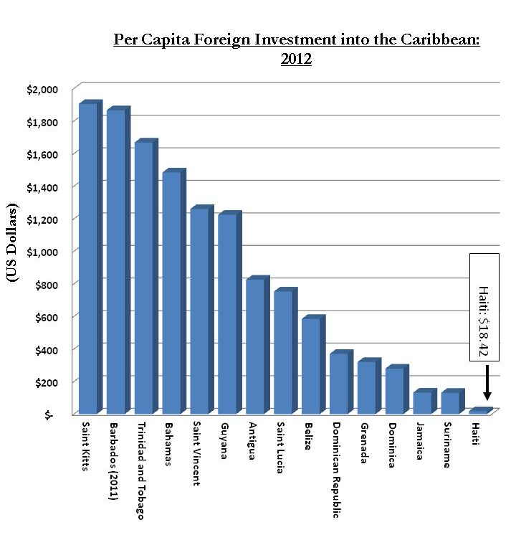
Once again, the West’s soothing words to Haiti have not been followed by concrete help on the ground; once again the West has failed to live up to its grand promises; once again the Haitian people are left to ponder: Whatever became of all the promised help? After all the big talk, Western capitalism continues to have a negligible impact on the lives of ordinary Haitians – eighteen dollars and forty-two cents, to be exact.
© July 2013, S. Brian Samuel
Stevenbriansamuel@gmail.com
1-473-420-1903

